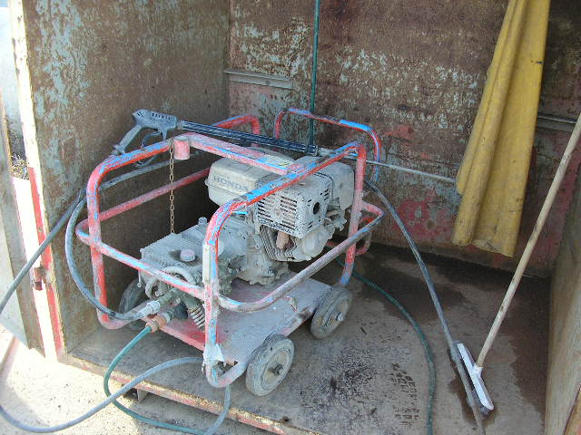 | Hazard Information Sheet
  Equipment: | H.P Washers
 | Equip Type: | H.P Washers
 | Generic Description or  Specific Make / Model: | H.P Washers
 | Type:
 | Other Details

Operator Requirements: | Operators must be trained and competent to use this equipment safely.
Purpose For Which This Equip Is Designed: | A portable high pressure washer

Hazards & Risks:
Control Measures:
High Pressure / Other Substances :  High Pressures cause bodily harm | (i) Never try to bind up leaking connections or hoses.  (ii) Never use the hose to drag the machine around.  (iii) Never point gun at or direct hp water at anyone.
High Pressure / Other Substances:  High Pressure lance & pistol may cause damage to personnel and/or machinery | (i) Before pulling trigger grasp lance & piston firmly with both hands. Adopt proper body stance to anticipate recoil force by spray gun. Exercise care and caution when spraying.  (ii) Lock the pistol with the safety switch during pauses and stops but never override the automatic trigger release mechanism to hold trigger in open position.  (iii) Do not leave the gun unattended while the machine is running.

Disclaimer: In fulfilment of its statutory obligations, (ARS) & John Holland has taken what it considers to be all reasonable precautions and exercised due diligence to ensure that it has provided all relevant information on the safe use of the plant. However, except as required by law and only to the extent so required, (ARS) & John Holland does not make any representation, warranty or undertaking, express or implied, as to, or accept any responsibility or liability for, the accuracy or completeness of, or any errors in or omissions from, this Hazard Information Sheet. Except as required by law and only to the extent so required, neither (ARS) & John Holland nor any of its respective directors, officers, agents, or employees shall in any way be liable directly or indirectly to any person or body for any loss or damages, costs or expenses whatever arising out of or in connection with the information contained in this Hazard Information Sheet. | Date: 19/06/06
Equipment: | HP Washer

Hazards & Risks: | Control Measures:
Electrical :  Electrical shock or burns due to damaged leads or plugs | (i) Operator to ensure no damage to electrical cord or plug and use with RCD protected power supply.  (ii) Ensure cord is not positioned in or near water, nor likely to get damaged by falling objects, pedestrians or other traffic.  (iii) When cleaning electrical devices, always disconnect the power supply.
High Temperature or Fire :  High temperature water spray will scald if directed on skin | (i) Do not direct the jet of water on bystanders or animals nor test water temp by placing your fingers in front of gun.  (ii) When spraying hot liquids avoid hand or body contact with non-insulated parts of the extension and inlet body of gun.
Refuelling : When refuelling, hot engine can ignite fuel | Operator responsible to shut engine down prior to refuelling.  Refuel in a well-ventilated area. Ensure there are no naked flames in the area. DO NOT SMOKE.  Avoid spilling fuel and collect any fuel run off.
Suffocation:  Using air from this compressor for breathing. | Operator/User responsible to use engine driven machine in a well-ventilated area.
PPE  Safety Equipment | Hearing protection, particle mask, respirator, goggles & gloves.

Disclaimer: In fulfilment of its statutory obligations, (ARS) & John Holland has taken what it considers to be all reasonable precautions and exercised due diligence to ensure that it has provided all relevant information on the safe use of the plant. However, except as required by law and only to the extent so required, (ARS) & John Holland does not make any representation, warranty or undertaking, express or implied, as to, or accept any responsibility or liability for, the accuracy or completeness of, or any errors in or omissions from, this Hazard Information Sheet. Except as required by law and only to the extent so required, neither (ARS) & John Holland nor any of its respective directors, officers, agents, or employees shall in any way be liable directly or indirectly to any person or body for any loss or damages, costs or expenses whatever arising out of or in connection with the information contained in this Hazard Information Sheet. | Date: 19/06/06

